**Assignment 1 – Module 5**

**Query for Problem 9:**

**DELETE FROM LOCATION**

**WHERE LOCNO = ‘L108’;**

**Snapshot for the Problem:**

1. **Before Updating the query**

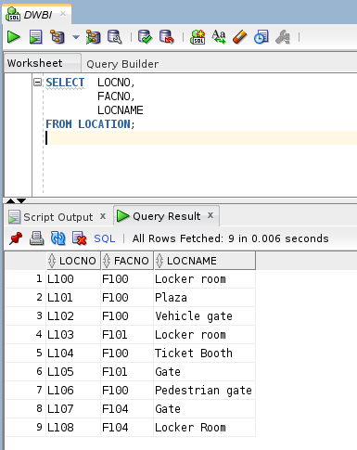

1. **Executing the Delete query**

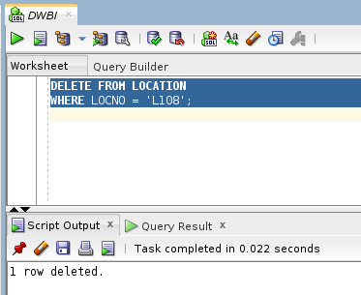

1. **After executing the query**

